
DEPARTMENT OF CSE

MID-II EXAMINATION
Year/Sem :II B.Tech, I Sem | Programme: CSE, AIML & AIDS | Course Code: 23BS301D
Course Name: DM & GT | Total marks:30 | Time:90 min
CO: Course outcome Level: Bloom’s Taxonomy (Level1-6)
Answer all questions
CO.no | Level | Q.No | Question
CO4 | a)3  b) 3  c) 3 | 1 | a) How many Positive integers $n$ can we form using the digits 3, 4, 4, 5, 5, 6, 7. if we want $'n'$ to Exceed 5,000,000 (5M) b) A certain question paper contains three parts A, B, C with four questions in part A, five questions in part B and six questions in part C. It is required to answer seven questions selecting at least two questions from each part. In how many ways can a student select his seven questions from answering? (5M)  (OR)  c) Solve the R.R $a_{n}+4a_{n-1}+4a_{n-2}=8 for n≥2 and a_{0}=1, a_{1}=2$ (10M)
CO5 | a)1  b)1  c)1 | 2 | a) Explain Euler Path, Euler Circuit and Euler graph in a multigraph with suitable examples. (5M)  b) Explain Hamilton Cycle, Hamilton Path and Hamilton graph with suitable examples. (5M)  (OR)  c) Define Isomorphism of two graphs. Explain with examples. (10M)
CO6 | a) 2  b) 2  c) 2 | 3 | a) Prove that $c_{6}$ is a bipartite graph (5M)  b) How many vertices and how many edges are there in Complete Bipartite graphs $k_{4, 7}$ and $k_{7, 11}$ (5M)  (OR)  c) Find the minimal spanning tree for the following graph using Prim’s algorithm (10M)  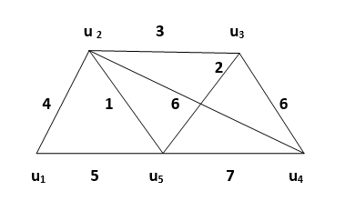
COURSE OUTCOMES:
CO1. Build skills in solving mathematical problems (L3)
CO2. Comprehend mathematical principles and logic (L4)
CO3.Demonstrate knowledge of mathematical modeling and proficiency in using mathematical software (L6)
CO4. Manipulate and analyze data numerically and/or graphically using appropriate Software (L3)
CO5. How to communicate effectively mathematical ideas/results verbally or in writing (L1)
CO6. Understanding various concepts of graphs and spanning trees (L2)

USHA RAMA COLLEGE OF ENGINEERING AND TECHNOLOGY
DEPARTMENT OF CSE & AI
ASSIGNMENT-II
Year/Sem :II B.Tech, I Sem | Programme: CSE, AIML & AIDS | Course Code: 23BS301D
Course Name: DM & GT | Total marks:30 | Time:90 min
CO: Course outcome Level: Bloom’s Taxonomy (Level1-6)
Answer all questions
CO.no | Level | Q.No | Question
CO4 | a) 3  b) 3  c) 3  d) 3 | 1 | a) Find the coefficient of $x^{101}y^{99}$ in the expansion of ${\left(2x-3y\right)}^{200}$ (5M)  b) Find the number of integer solutions of $x_{1}+x_{2}+x_{3}+x_{4}+x_{5}=30 where x_{1}≥2, x_{2}≥3,x_{3}≥4, x_{4}≥2, x_{5}≥0$ (5M)  (OR)  c) Find the generating functions for the following sequence  $i) 1, 2, 3, 4, …… ii) 1, \frac{1}{1!}, \frac{1}{2!}, \frac{1}{3!}, ……..$. (5M)  d) Solve the R.R $F_{n+2}=F_{n+1}+F_{n} for n≥0, given F_{0}=0, F_{1}=1$ (5M)
CO5 | a)1  b)1  c) 1 | 2 | a) Find the number of vertices, the number of edges, and the degree of each vertex in the given undirected graph. Identify all isolated and pendant vertices. (5M)  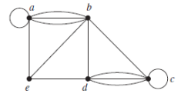  b) Prove that the following graphs are Hamiltonian but not Eulerian. (5M)  (OR)  c) Show that the following two graphs are isomorphic. (10M)  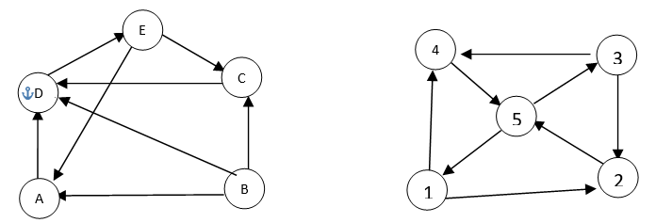
CO6 | a) 2  b) 2 | 3 | a) Show that the Bipartite graphs K_{2, 2} and K_{2, 3}are planar graphs.  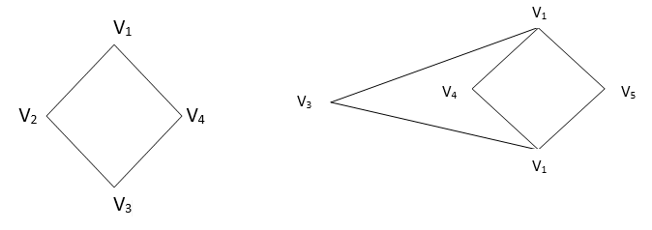(10M)  (OR)  b) Using BFS & DFS algorithm, find the spanning tree for the following graph (10M)  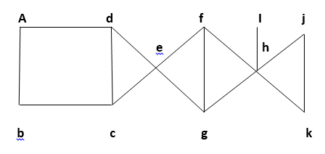
COURSE OUTCOMES:
CO1. Build skills in solving mathematical problems (L3)
CO2. Comprehend mathematical principles and logic (L4)
CO3.Demonstrate knowledge of mathematical modeling and proficiency in using mathematical software (L6)
CO4. Manipulate and analyze data numerically and/or graphically using appropriate Software (L3)
CO5. How to communicate effectively mathematical ideas/results verbally or in writing (L1)
CO6. Understanding various concepts of graphs and spanning trees (L2)

